Type the Title of the Paper, Capitalize First Letter
First Author ^{a,} (), Second Author ^{b,} , Third Author ^{a,c,}
ª First affiliation, City, Country
http://yourorganization.web.page
^{b} Second affiliation, City, Country
http://yourorganization2.web.page
^{c} Third affiliation, City, Country
http://yourorganization3.web.page
Abstract:
Brief description of the study objectives, observations/ experiments performed, resulting data, other key evidence, structure of the article, main findings.
Do not include references in the abstract.
Length – between 150 and 200 words max.

Article Info:  Received: xx Dec 2020  Revised: yy Jan 2020  Online: zz Feb 2020 | Keywords:  4-6 comma separated keywords or phrases  Creative Commons BY-NC 4.0

Introduction
Outline the motivation for the study and its purpose. Describe the study design, the data generated, any background information needed to put the study in the context of previous work and the literature.
Reference literature sources as needed (see also the section on the reference style below).
Indicate the potential for using the study results.
Outline the content of the article.

Methods
This section provides a detailed description on the methods and procedures used in the study, and how they were selected among relevant methods.
Provide a description of the methods that is sufficiently complete, so that a reader is able understand and eventually reproduce the methods and processing steps without referring to associated publications.

Guidance on Language, Formatting and Style
Sections and sub-sections can be numbered or not, depending on the preference of the author(s).

Spelling and Format
Authors from the United States are welcome to use U.S. spelling. All other authors, please use consistently U.K. spelling. For referenced sources, use the title as given in the original publication.
Bulleted lists may be included and should look like this:
- First point
- Second point
- And so on
- Last bullet point.
Please do not alter the formatting and style layouts which have been set up in this template document.
Page numbers will be added by the publisher.

Tables
All tables should be numbered with Arabic numerals. Every table should have a caption, placed above the table, left justified. Only horizontal lines should be used within a table, to distinguish the column headings from the body of the table, and immediately above and below the table. Tables must be embedded into the text and not supplied separately. Below is an example which the authors may find useful.
Please make sure that the table is not split between pages. Try to position each table at the top or the bottom of the page.

Charts, Figures, Photos
All figures should be numbered with Arabic numerals (1,2,3,….). Every figure should have a caption, located below the figure. All photographs, schemas, graphs and diagrams are to be referred to as figures. Line drawings should be good quality scans or true electronic output. Low-quality scans are not acceptable.
Figures must be embedded into the text and not supplied separately. In MS word input the figures must be properly coded. Lettering and symbols should
Table 1. An example of a table.

An example of a column heading | Column A  (t) | Column B  (h) | Column C (m) | Column D (deg) | Column E  (t)
And an entry | 1 | 2
And another entry | 3 | 4
And another entry | 5 | 6

be clearly defined either in the caption or in a legend provided as part of the figure. Figures should be placed at the top or bottom of a page wherever possible, as close as possible to the first reference to them in the paper.
The figure number and caption should be typed below the illustration in 11 pts and left justified.

Construction of References
Use endnotes to cite a source in the text and/or provide clarification. Use font size 11 pts and single-spaced paragraphs. You can include more than one source in an endnote, separated by a semicolon (;).
For the referenced sources Information & Security: An International Journal (ISIJ) applies the Chicago Manual of Style, the style for notes Please consult the Guide at www.chicagomanualofstyle.org/. A quick guide is available at www.chicagomanualofstyle.org/tools_citationguide/citation-guide-1.html.
When you reference a source for a second or third time, use a short citation (not “Ibid.”).
At the end of the referenced source include its DOI number. If a DOI is not available, include the most recent working URL of the source.

Licenses
Authors who publish with ISIJ will retain all intellectual property rights, including moral rights in their work. The article will be licensed to the public under “Creative Commons 4.0 Attribution-NonCommercial” International license (CC BY-NC 4.0).
It is the responsibility of the author(s) of the article to verify that the original license pertaining is compatible with the subsequent issuance by ISIJ under the CC 4.0 BY-NC license.

Conclusions
Once ready with the text, please hyphenate it using the feature incorporated in Word for Windows. Select ‘Manual’ hyphenation and do not hyphenate titles, URL addresses and the like. Avoid also hyphenation at the end of a line.
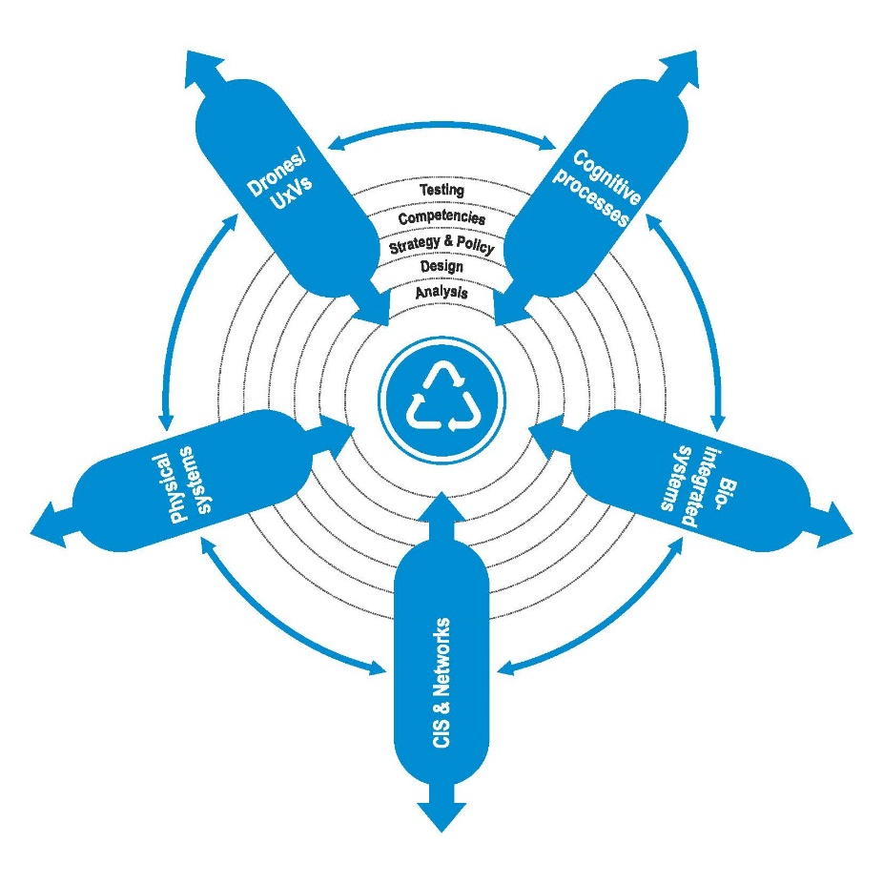
Figure 1: Insert Figure Caption here (Sample illustration).

Once a paper is accepted and ready for online publication, the publisher will include it in the respective volume and issue of ISIJ, will insert page numbers and assign a DOI to it.

Acknowledgements
Acknowledgements and Reference heading should be left justified, bold, with the first letter capitalized but have no numbers. Text below continues as normal.

About the Author(s)
Please provide a short CV of 4 to 6 lines of text. For the purposes of disambiguation mark the OCID ID icon after the name and, using Ctrl+K, insert the respective ORCID ID. If you do not have one, you may consider creating your profile by signing in at https://orcid.org/.

References

Todor, Tagarev, George Sharkov, and Nikolai Stoianov, “Cyber Security and Resilience of Modern Societies: A Research Management Architecture,” Information & Security: An International Journal 38 (2017): 93-108, https://doi.org/10.11610/isij.3807.
Sara Hugelier, “Publishing Open-Access Biomedical Data: Legal Challenges,” Biomedical Data Journal 1, no. 1 (2015):43-51, http://dx.doi.org/10.11610/bmdj.01108.
Creative Commons, “Attribution-NonCommercial 4.0 International license,” https://creativecommons.org/licenses/by-nc/4.0/legalcode, accessed February 19, 2019.

